Cloud services

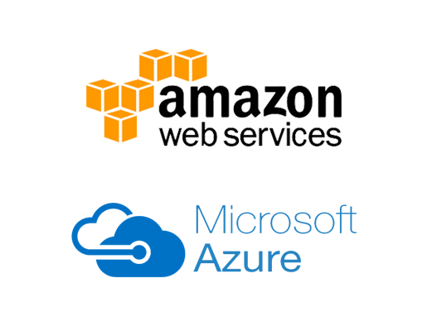

Name: Victoria C. A. Fong

Student Number: 488384

# Introduction

This document is based on looking into the top 2 largest cloud service providers (Amazon AWS, Microsoft Azure) to what is important for the Care web application as cloud service provider.

The provider will be chosen based on different criteria such as ease of use, pricing and security.

Table of Contents

Introduction 2

Ease of use 4

Aws 4

Azure 4

Conclusion 4

Cloud security 5

AWS 5

Azure 5

Conclusion 5

Costs 6

AWS 6

Azure 7

Pricing from school 8

Conclusion 8

Criteria overview 9

Conclusion 10

Sources 11

## Ease of use

### Aws

* Recommended for newcomer and people who are unfamiliar with cloud platforms.
* Feature-rich, straightforward dashboard.
* Comprehensive documentation.
* Handling users and access is a bit complex.

### Azure

* Adding users and access is maintained in a single directory.
* Lack of documentation and recommendations.

### Conclusion

To conclude, Aws is the winner for ease of use, for the reason that the service is recommended for people unfamiliar with cloud platforms such as myself and the extensive documentation they provide.

## Cloud security

### AWS

Aws is one of the most mature cloud providers with extensive documentation, knowledge and trained experts.

Aws list of infrastructure security:

* Security development lifecycle (SDL) - A set of practices that “help developers build more secure software by reducing the number and severity of vulnerabilities in software, while reducing development cost.”
* Intrusion and DoS detection.
* Network access control

### Azure

Azure can’t compare to AWS and is outperformed by the service regarding security. The reason to why azure is mostly used, is that many companies have a relationship with Microsoft.

Azure critical security points:

* Security development lifecycle (SDL) - A set of practices that “help developers build more secure software by reducing the number and severity of vulnerabilities in software, while reducing development cost.”
* Intrusion and DoS detection.
* Network access control

### Conclusion

When it comes to security AWS is better in that regards with extensive documentation.

## Costs

Using the AWS and Azure price calculator and basing the service and amount I would be using from each service did I have a total amount to what I would be spending.

### AWS

Using [AWS pricing calculator](https://calculator.aws/#/), I have come to realize that the best service that AWS offers that fits the project is Amazon Elastic Block Store.

#### Pricing

#### Amazon Elastic Block Store (EBS)

Elastic Block Store (Amazon EBS) is an easy-to-use, scalable, high-performance block-storage service designed for Amazon Elastic Compute Cloud (Amazon EC2).

### Azure

Using [Azure Price calculator](https://azure.microsoft.com/en-us/pricing/calculator/), have I come to a decision the best service is the AKS (Azure Kubernetes Service). The reason for this is that it best fits the profile of the project.

#### Pricing

#### Azure Kubernetes Service (AKS)

Azure Kubernetes Service (AKS) offers the quickest way to start developing and deploying cloud-native apps in Azure, datacenters, or at the edge with built-in code-to-cloud pipelines and guardrails. Get unified management and governance for on-premises, edge, and multi-cloud Kubernetes clusters. Interoperate with Azure security, identity, cost management, and migration services.

Paying for only the virtual machines, and associated storage and networking resources consumed makes AKS the most efficient and cost-effective container service on the market.

### Pricing from school

The school offers 500 euro for using Azure where with AWS you would have to use AWS Educate where there can be limitations to.

### Conclusion

When it comes to costs, Azure is more on the high end compared to AWS to what is needed for the project which is why preference would be AWS but for the reason to what school offers in clear description to Azure than AWS is Azure the winner in this category.

# Criteria overview

selection criteria

|  |  |  |
| --- | --- | --- |
|  | Azure | AWS |
| Ease of use |  |  |
| Pricing |  |  |
| Security |  |  |

# Conclusion

For this project will Azure be used a Service Provider. Overall the two providers are quiet well, there are some differences but the main factor for choosing this provider is the costs factor and the experience I have gotten to work with Azure more than AWS.

# Sources

<https://itoutposts.com/blog/microsoft-azure-vs-aws-feature-comparison/>

<https://www.codemotion.com/magazine/devops/cloud/aws-vs-azure-cost-comparison/>

<https://www.makeuseof.com/tag/aws-vs-azure-cloud-service/>

<https://cloudindustryforum.org/8-criteria-to-ensure-you-select-the-right-cloud-service-provider/>

<https://www.threatstack.com/blog/7-factors-to-help-you-choose-the-right-cloud-service-provider>

<https://intellipaat.com/blog/aws-vs-azure-vs-google-cloud/>